1. Answer the questions following perceptron learning:

0.4

0.2

0.7

Input

Neurons

Output

Neuron

Weights

0.1

Bias

1

0

1

1. The input of the output neuron is:

1*0.4+0*0.2+1*0.7+0.1=1.2

1. If the transfer function of output neuron is ReLU, what is the output of output neuron?

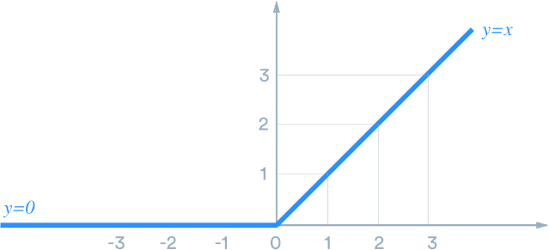

Now input is 1.2, which is larger than 0. We are at the right side of the curve, so then the output is 1.2

1. If the desired output is 0 and the updating formula is given by

*wnew = wold +* α ×*(desired - output)* × *input*

* + 1. In NN’s terminology, what is α called?

Learning rate

II. Suppose α=1, please update all weights.

W1new = 0.4 + 1*(0-1.2)*1 = -0.8

W2new = 0.2 + 1*(0-1.2)*0 =0.2

W3new = 0.7 + 1*(0-1.2)*1 = -0.5

1. What is the output after you adjust all w for this round?

After updating the weights, the input of the ourput neuron now is

1*(-0.8) + 0*0.2 + 1*(-0.5)+0.1 = -1.2

Since it is negative, we are at the left side of the transfer function curve, the out put is 0.

1. You are provided with the below set of transactions. The data consists of three variables: student (with two levels, Yes or No), Credit Rating (with two levels Fair or Excellent), and Buy iPhone (with two levels, Yes for buying the phone and No for not buying). We are trying to predict whether a customer will buy an iPhone. This will help us decide the future target customers in our mailing campaign. For this prediction activity, we run two classifiers and obtain their prediction against the actual class (last two columns).

|  |  |  |  |  |  |
| --- | --- | --- | --- | --- | --- |
| **Observed Data** | | | | **Classifier 1** | **Classifier 2** |
| Customer  ID | Student | Credit Rating | Actual Class: Buy iPhone | Predicted Class: Buy iPhone | Predicted Class: Buy iPhone |
| 1 | No | Fair | **No** | ***Yes*** | ***No*** |
| 2 | No | Excellent | **No** | ***No*** | ***No*** |
| 3 | No | Fair | **Yes** | ***No*** | ***Yes*** |
| 4 | No | Fair | **Yes** | ***Yes*** | ***Yes*** |
| 5 | Yes | Fair | **Yes** | ***No*** | ***Yes*** |
| 6 | Yes | Excellent | **No** | ***Yes*** | ***No*** |
| 7 | Yes | Excellent | **Yes** | ***Yes*** | ***Yes*** |
| 8 | No | Excellent | **No** | ***No*** | ***No*** |
| 9 | Yes | Excellent | **No** | ***Yes*** | ***No*** |
| 10 | Yes | Excellent | **Yes** | ***Yes*** | ***Yes*** |

* 1. Create a separate confusion matrix for each of the classifiers

Classiifier 1

|  |  |  |
| --- | --- | --- |
|  | Predicted Positive | Predicted Negative |
| Actual Positive | 3 | 2 |
| Actual Negative | 3 | 2 |

Classiifier 2

|  |  |  |
| --- | --- | --- |
|  | Predicted Positive | Predicted Negative |
| Actual Positive | 5 | 0 |
| Actual Negative | 0 | 5 |

* 1. Calculate the accuracy, precision, recall of each of the classifiers.

Classifier 1: accu = 5/10 = 50% precision 3/(3+3) =50% Recall = 3/(3+2) = 60%

Classifier 2: accu = 10/10 = 100% precision 5/(5+0) =100% Recall = 5/(5+0) = 100%

* 1. Assume the cost of classifying a buyer as a non-buyer is $2 and the cost of classifying a non-buyer as a buyer is $5. All other costs are 0. Calculate the misclassification cost of each of the classifiers. Which one will you chose? Why?

Classifier 1: 2*$2 + 3*$5 = 19$

Classifier 2: 0$

Choose classifier 2